Lab 7
Web programming

Name : umar ahad uddin ahmed usmani
Sap : 60199
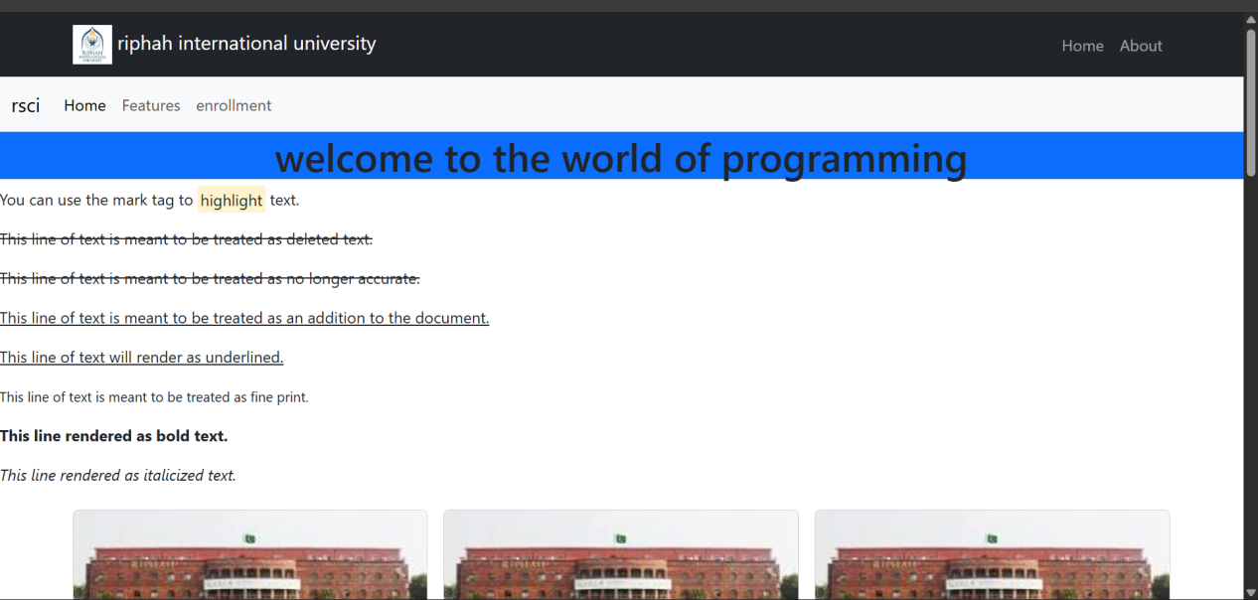

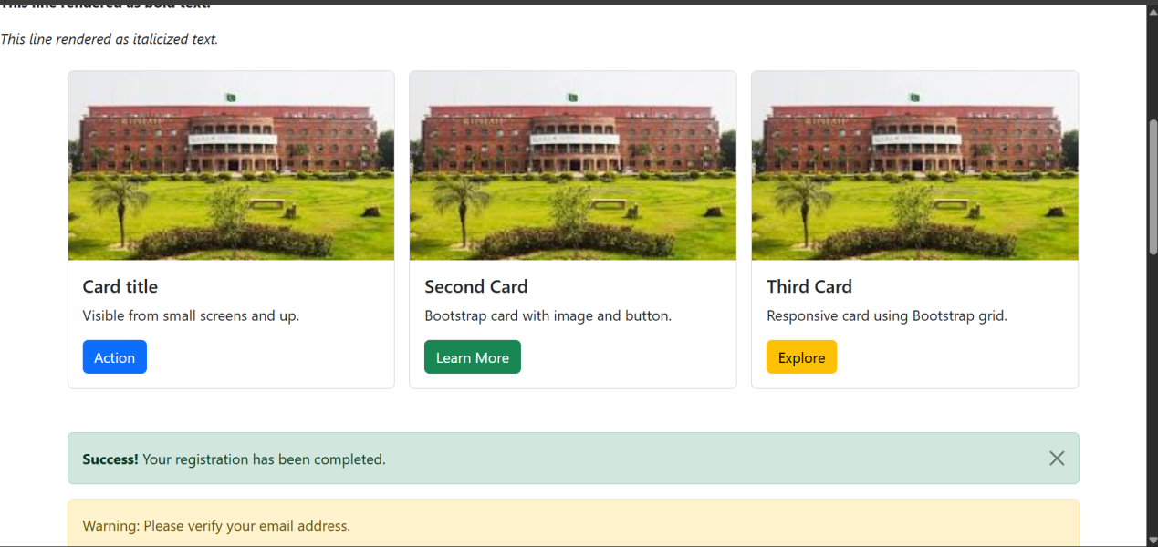

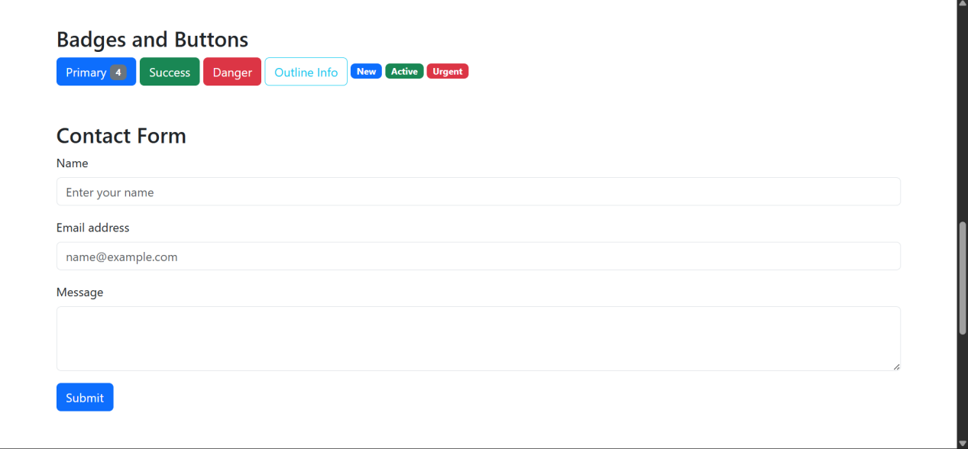

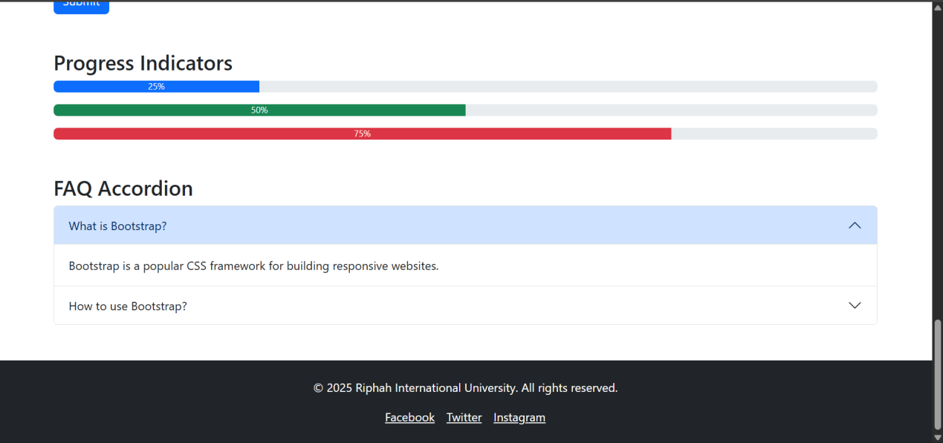

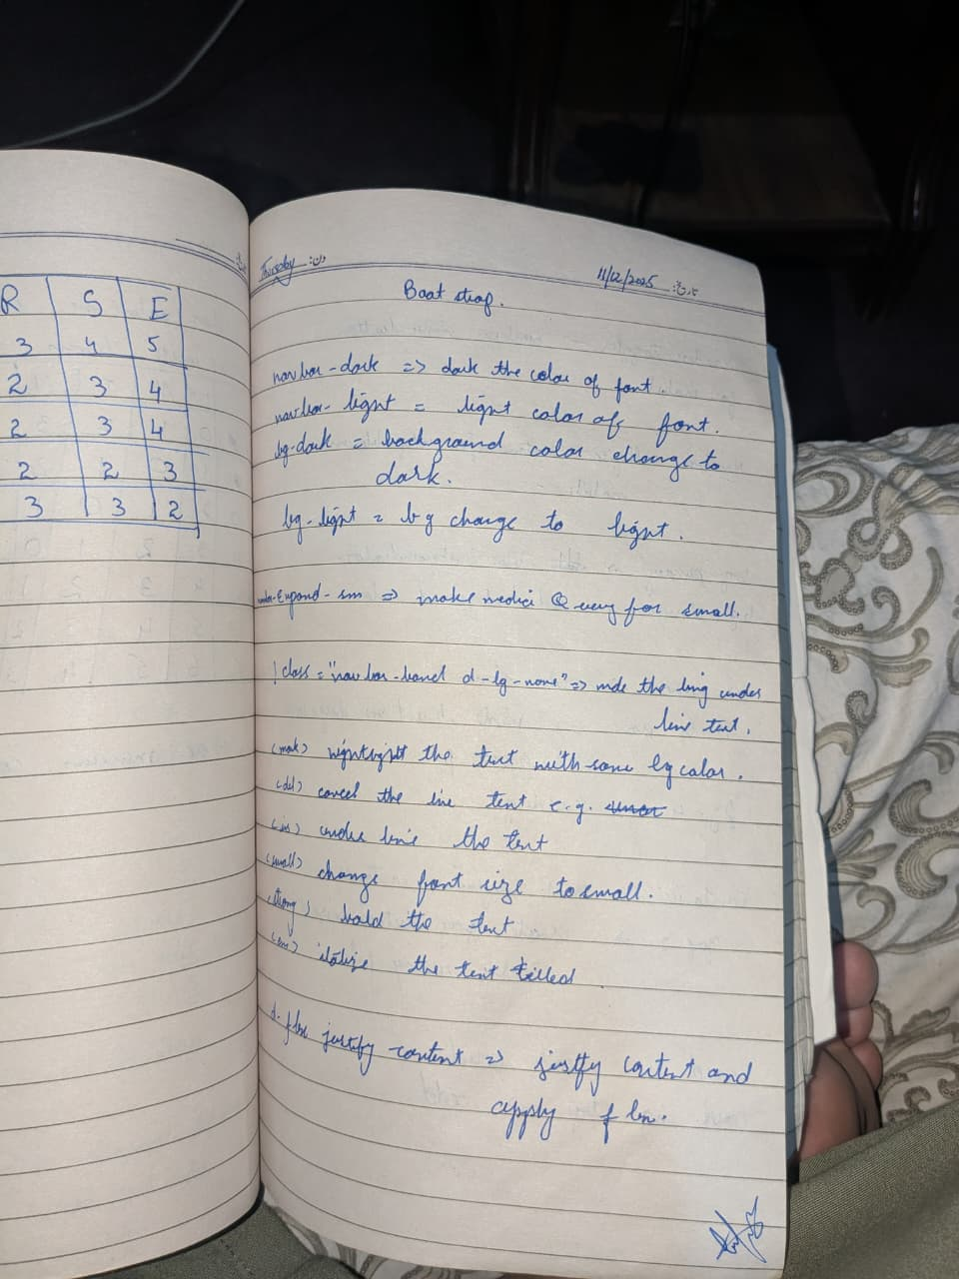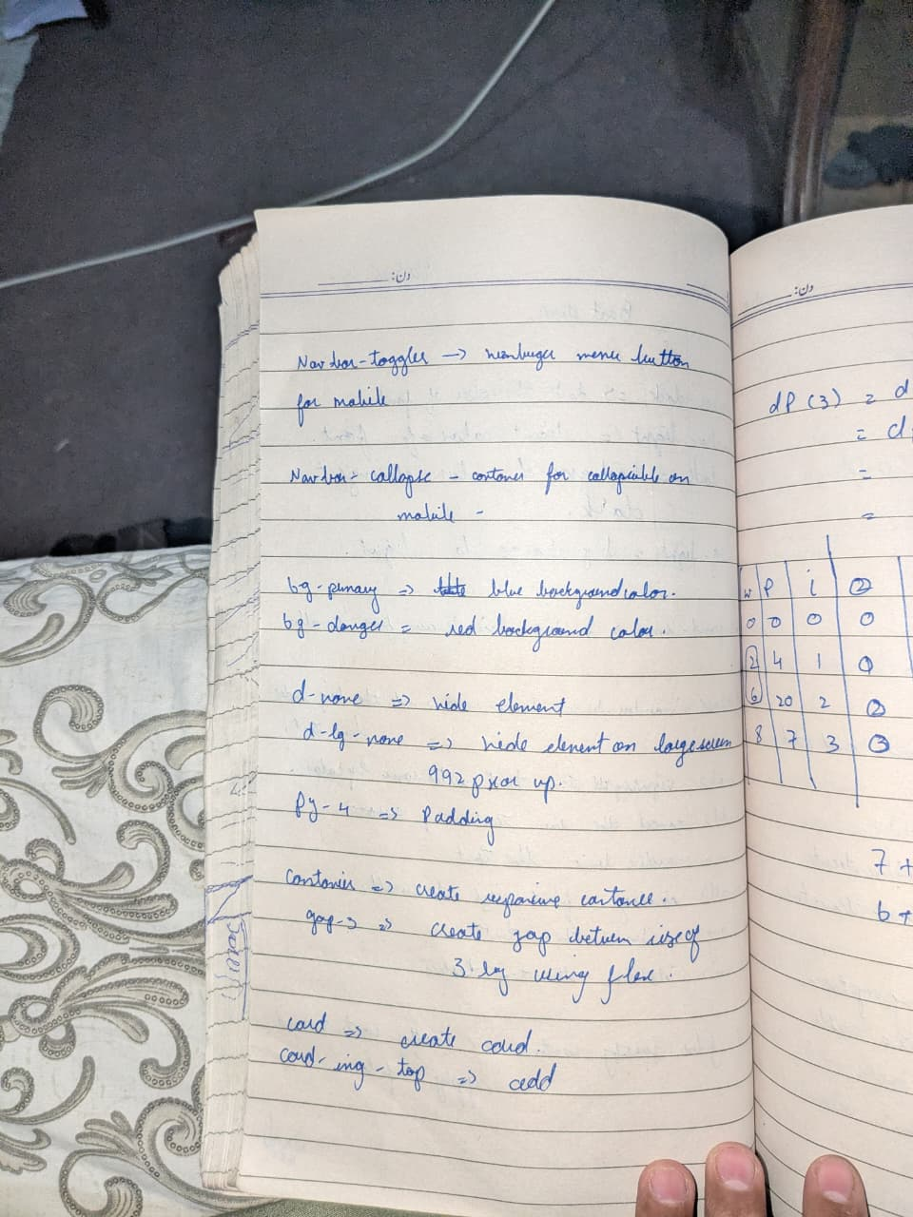

<!DOCTYPE html>
<html lang="en">
<head>
<meta charset="UTF-8">
<meta name="viewport" content="width=device-width, initial-scale=1.0">
<link href="https://cdn.jsdelivr.net/npm/bootstrap@5.3.2/dist/css/bootstrap.min.css" rel="stylesheet">
<title>lab 7 </title>
</head>
<body>

<nav class="navbar navbar-expand-sm navbar-dark bg-dark">
<div class="container">
<a class="navbar-brand d-none d-lg-block" href="#">
<img src="riphah.jpg" width="40"> riphah international university
</a>
<a class="navbar-brand d-lg-none " href="#">riphah international university </a>
<button class="navbar-toggler" type="button" data-bs-toggle="collapse" data-bs-target="#navMenu">
<span class="navbar-toggler-icon"></span>
</button>
<div class="collapse navbar-collapse" id="navMenu">
<ul class="navbar-nav ms-auto">
<li class="nav-item"><a class="nav-link" href="#">Home</a></li>
<li class="nav-item"><a class="nav-link" href="#">About</a></li>
</ul>
</div>
</div>
</nav>
<nav class="navbar navbar-expand-lg bg-body-tertiary">
<div class="container-fluid">
<a class="navbar-brand" href="#">rsci</a>
<button class="navbar-toggler" type="button" data-bs-toggle="collapse" data-bs-target="#navbarNav" aria-controls="navbarNav" aria-expanded="false" aria-label="Toggle navigation">
<span class="navbar-toggler-icon"></span>
</button>
<div class="collapse navbar-collapse" id="navbarNav">
<ul class="navbar-nav">
<li class="nav-item">
<a class="nav-link active" aria-current="page" href="#">Home</a>
</li>
<li class="nav-item">
<a class="nav-link" href="#">Features</a>
</li>
<li class="nav-item">
<a class="nav-link" href="#">enrollment</a>
</li>
</ul>
</div>
</div>
</nav>

<h1 class="d-flex justify-content-center bg-primary " >welcome to the world of programming</h1>

<p >You can use the mark tag to <mark>highlight</mark> text.</p>
<p><del>This line of text is meant to be treated as deleted text.</del></p>
<p><s>This line of text is meant to be treated as no longer accurate.</s></p>
<p><ins>This line of text is meant to be treated as an addition to the document.</ins></p>
<p><u>This line of text will render as underlined.</u></p>
<p><small>This line of text is meant to be treated as fine print.</small></p>
<p><strong>This line rendered as bold text.</strong></p>
<p><em>This line rendered as italicized text.</em></p>

<div class="container mt-4">
<div class="row g-3">
<div class="col-12 col-md-6 col-lg-4">
<div class="card">
<img src="riphah2.jpg" class="card-img-top" alt="...">
<div class="card-body">
<h5 class="card-title">Card title</h5>
<p class="card-text d-none d-sm-block">Visible from small screens and up.</p>
<a href="#" class="btn btn-primary">Action</a>
</div>
</div>
</div>
<div class="col-12 col-md-6 col-lg-4">
<div class="card">
<img src="riphah2.jpg" class="card-img-top" alt="...">
<div class="card-body">
<h5 class="card-title">Second Card</h5>
<p class="card-text">Bootstrap card with image and button.</p>
<a href="#" class="btn btn-success">Learn More</a>
</div>
</div>
</div>
<div class="col-12 col-md-6 col-lg-4">
<div class="card">
<img src="riphah2.jpg" class="card-img-top" alt="...">
<div class="card-body">
<h5 class="card-title">Third Card</h5>
<p class="card-text">Responsive card using Bootstrap grid.</p>
<a href="#" class="btn btn-warning">Explore</a>
</div>
</div>
</div>
</div>
</div>

<!-- Alert Section -->
<div class="container mt-5">
<div class="alert alert-success alert-dismissible fade show" role="alert">
<strong>Success!</strong> Your registration has been completed.
<button type="button" class="btn-close" data-bs-dismiss="alert" aria-label="Close"></button>
</div>
<div class="alert alert-warning" role="alert">
Warning: Please verify your email address.
</div>
<div class="alert alert-danger" role="alert">
Error: Invalid credentials entered.
</div>
</div>

<!-- Badges and Buttons -->
<div class="container mt-5">
<h3>Badges and Buttons</h3>
<button class="btn btn-primary">Primary <span class="badge bg-secondary">4</span></button>
<button class="btn btn-success">Success</button>
<button class="btn btn-danger">Danger</button>
<button class="btn btn-outline-info">Outline Info</button>
<span class="badge bg-primary">New</span>
<span class="badge bg-success">Active</span>
<span class="badge bg-danger">Urgent</span>
</div>

<!-- Form Section -->
<div class="container mt-5">
<h3>Contact Form</h3>
<form>
<div class="mb-3">
<label for="name" class="form-label">Name</label>
<input type="text" class="form-control" id="name" placeholder="Enter your name">
</div>
<div class="mb-3">
<label for="email" class="form-label">Email address</label>
<input type="email" class="form-control" id="email" placeholder="name@example.com">
</div>
<div class="mb-3">
<label for="message" class="form-label">Message</label>
<textarea class="form-control" id="message" rows="3"></textarea>
</div>
<button type="submit" class="btn btn-primary">Submit</button>
</form>
</div>

<!-- Progress Bars -->
<div class="container mt-5">
<h3>Progress Indicators</h3>
<div class="progress mb-3">
<div class="progress-bar" role="progressbar" style="width: 25%">25%</div>
</div>
<div class="progress mb-3">
<div class="progress-bar bg-success" role="progressbar" style="width: 50%">50%</div>
</div>
<div class="progress">
<div class="progress-bar bg-danger" role="progressbar" style="width: 75%">75%</div>
</div>
</div>

<!-- Accordion -->
<div class="container mt-5">
<h3>FAQ Accordion</h3>
<div class="accordion" id="accordionExample">
<div class="accordion-item">
<h2 class="accordion-header">
<button class="accordion-button" type="button" data-bs-toggle="collapse" data-bs-target="#collapseOne">
What is Bootstrap?
</button>
</h2>
<div id="collapseOne" class="accordion-collapse collapse show" data-bs-parent="#accordionExample">
<div class="accordion-body">
Bootstrap is a popular CSS framework for building responsive websites.
</div>
</div>
</div>
<div class="accordion-item">
<h2 class="accordion-header">
<button class="accordion-button collapsed" type="button" data-bs-toggle="collapse" data-bs-target="#collapseTwo">
How to use Bootstrap?
</button>
</h2>
<div id="collapseTwo" class="accordion-collapse collapse" data-bs-parent="#accordionExample">
<div class="accordion-body">
Include Bootstrap CSS and JS files, then use predefined classes in your HTML.
</div>
</div>
</div>
</div>
</div>

<!-- Footer -->
<footer class="bg-dark text-white text-center py-4 mt-5">
<div class="container">
<p>&copy; 2025 Riphah International University. All rights reserved.</p>
<div class="d-flex justify-content-center gap-3">
<a href="#" class="text-white">Facebook</a>
<a href="#" class="text-white">Twitter</a>
<a href="#" class="text-white">Instagram</a>
</div>
</div>
</footer>

<script src="https://cdn.jsdelivr.net/npm/bootstrap@5.3.8/dist/js/bootstrap.bundle.min.js" integrity="sha384-FKyoEForCGlyvwx9Hj09JcYn3nv7wiPVlz7YYwJrWVcXK/BmnVDxM+D2scQbITxI" crossorigin="anonymous"></script>

</body>
</html>

